**Department of Computer Engineering**

**Human Body Size Estimation**

**BE Major Project – 1 (Semester VII)**

by

**Mr. Shriyash Karekar (42)**

**Mr. Aqueel Alam Khan (45)**

**Mr. Imran Ali Khan (46)**

Supervisor:

**Mr. Ashraf Siddiqui**

**A. System Architecture:**

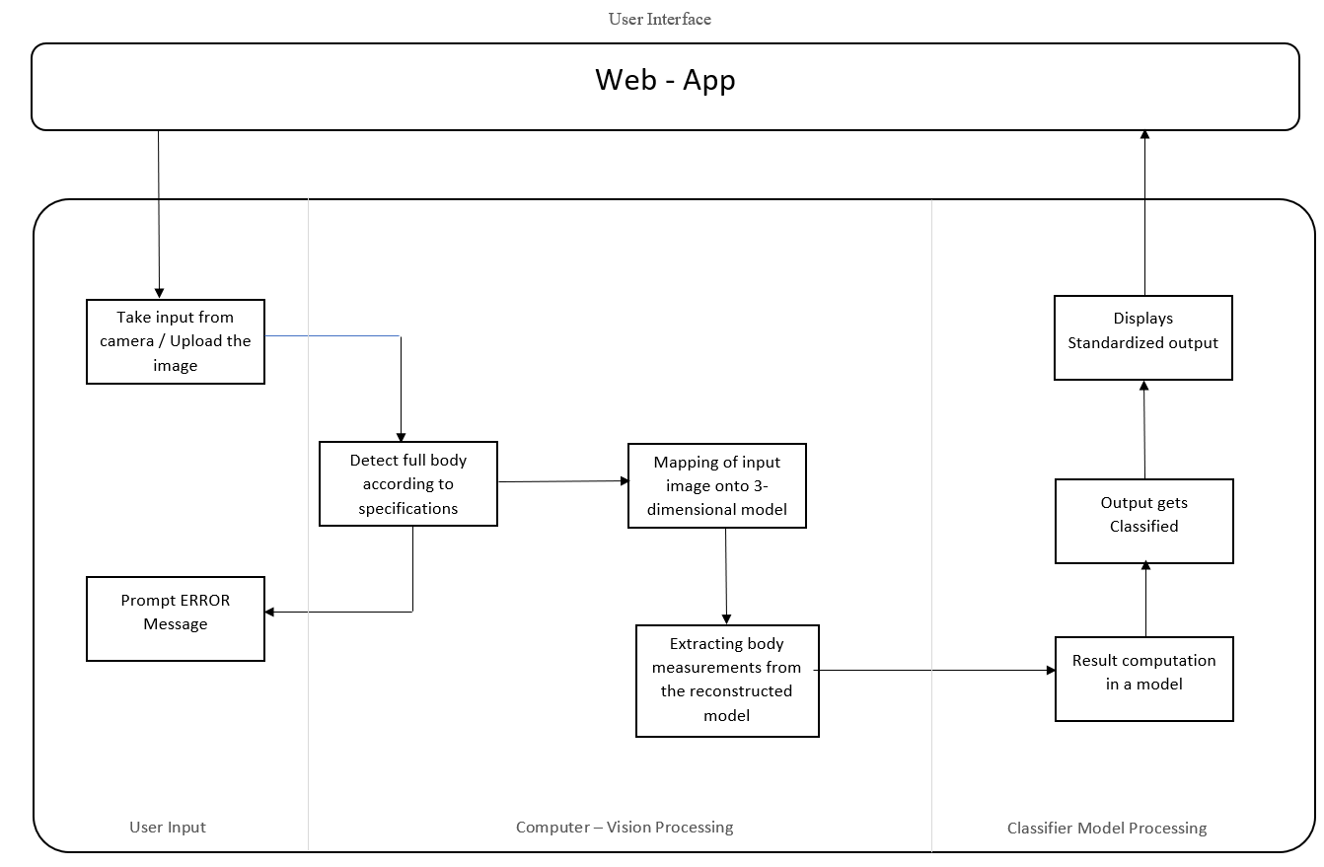

**B. Functionalities:**

1. Take input from camera / Upload the image
2. Detect full body according to specifications
3. Mapping of input image onto 3-dimensional model
4. Extracting body measurements from the reconstructed model.
5. Result computation in a model
6. Output gets Clustered
7. Displays Standardized output

Webapp will act as an interface between user and background process. In this input will to processed to the next stage likewise output will be displayed.

Take input from camera / Upload the image:

Initially, if the user wants to buy cloths, he has to capture the image through webapp’s camera by following the instructions given. The image will be captured if the conditions are satisfied or else user will be asked to recapture it.

Detect full body according to specifications:

Conditions such as the image captured should be at some specified distance from the camera, the body parts should be clearly visible etc. will be considered before processing. If this condition are satisfied image will be processed to further stage else it will display error message and will be prompted to recapture the image.

Mapping of input image onto 3-dimensional model using 3D human reconstruction:

We will encode the 3D mesh of a human body using the Skinned Multi-Person Linear (SMPL) which will create realistic 3D model of the human body that is based on skinning and blend shapes and is learned from thousands of 3D body scans. So, this model will reconstruct the 3D human model.

Extracting body measurements from the reconstructed model:

For extracting body measurements from reconstructed 3D model, we will be using Anthropometric body reshaping and extraction techniques.

Result computation in a model:

Results will be rounded off and the value obtained for parameters will be of height, waist, belly, chest, wrist, neck, etc. These parameters will be fed into classification model.

Output gets Classified:

The classification model will classify based on the parameters obtained with the standardized clothing size and will give appropriate results into S, M, L, etc.

Displays Standardized output:

The result obtained from classification model will be displayed to the user on the webapp.